Environment in the Classroom
www.umwelt-im-unterricht.de

Teaching materials (for primary schools)
From animals to people: the virus’s journey
Do blue fever, kangaroo hiccups and rabies really exist? An online quiz aims to raise students’ awareness of zoonotic diseases. By arranging texts and photos in the correct order, they gain an understanding of how infectious diseases are transmitted from animals to humans.

Guidance for teachers
What else can I find in this package of teaching materials?

The following pages contain teaching materials on the topic of the week: “Zoonotic diseases: When environmental crises lead to health crises” from the Environment in the Classroom initiative. The materials include background information and a lesson plan and can be downloaded here: https://www.umwelt-im-unterricht.de/wochenthemen/zoonosen-wenn-umweltkrisen-zu-gesundheitskrisen-fuehren/
Content and use of the teaching materials

Zoonotic diseases are explored in a quiz that provides a lively introduction to the topic. The package includes the questions from the quiz (Worksheet 1) and a text and photo matching exercise (Worksheet 2).

How are zoonotic diseases transmitted to humans? This is the topic of Worksheet 2. It consists of a matching exercise with photos and short texts. The students cut out the texts and photos and arrange them in the correct order to produce three stories. To reduce the level of difficulty, students may work through each story separately.

Overview of teaching materials
Worksheet 1 Quiz: Viruses, animals and people 1
Worksheet 2 From animals to humans: the virus’s journey 2
Solutions for Worksheet 2 6
Image rights 6

Worksheet 1
Quiz: Viruses, animals and people

As well as the coronavirus, there are many other diseases that spread from animals to humans. What is true and what is false?

Task
Answer the following questions:

Which of the following diseases does not exist?
- Bird flu
- Kangaroo hiccups
- Swine flu

Which disease can be transmitted by mosquitoes?
- Yellow fever
- Blue fever
- Red-and-white tartan fever

Which disease can be transmitted by foxes and wild dogs?
- Ragies
- Rabies
- Ravies

When can diseases spread rapidly among animals?
- When animals don’t wear face masks.
- When too many animals live in tight spaces.
- When pets don’t wash their paws enough.

When can diseases pass from animals to humans?
- When a person touches an animal or is bitten or stung by an animal.
- When an animal gives someone a hard stare.
- When an animal and a human cough at the same time.

Why are humans catching diseases from animals more often?
- Animals don’t observe social distancing of 1.5 metres and get too close to people.
- Humans are interfering more and more with nature. They are changing or destroying the natural environment and have more contact with wild animals.
- Wild animals don’t have a healthy lifestyle, so they get sick more often.

Worksheet 2
From animals to humans: the virus’s journey

How do diseases such as COVID-19 pass from animals to people? Put the photos and texts in the correct order to find out.

Task
- Cut out the texts and photos.

- Read the texts carefully to the end. Find the correct photo for each text.

- Put the photos and texts in the correct order to form three short stories. The three topics are:
  - bats
  - wild geese
  - rats
There are three texts and three photos for each story.

- Stick the photos and texts onto a sheet of paper. Make sure they are in the correct order.

- Extra task: Think about what can be done, in each of the situations shown in the photos, to prevent disease from spreading.

A. B.
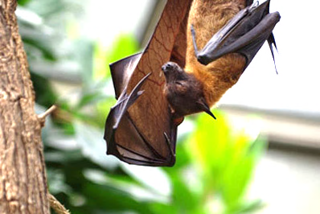

C.

1.
The hunter locks the different animals in small cages. He wants to sell them at the market. In such a crowded space, the bat virus quickly spreads. Now the pangolin has the virus too.
2.
The market is very crowded. A man buys the pangolin. He stays at the market for a long time. He talks to a lot of other people and shows them his new pet. The virus spreads.
3.
A bat lives deep in the forest. She is the carrier of a virus. But it doesn’t bother her or do her any harm. One day, she is caught by a hunter. He catches a pangolin and some other animals as well.

D. E.

F.
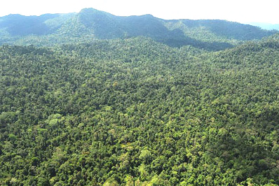

4.
One day, large vehicles come along and destroy the forest. The animals run away and move deeper into the rainforest. Here, they come across some rats, who they would normally never meet. The animals catch the virus from the rats.

5.
Lots of different animals live in a rainforest. Deep in the woods, there are rats that are infected with a virus. The virus gets passed around all the time, but the rats never get sick. They never leave their habitat, so the virus stays in the rainforest.
6.
Homes have been built where the forest was destroyed. People have moved in – and so have many rats from the rainforest. They like it much better here, outside the forest. They have lots of rat babies. One day, a man is bitten by a sick rat and falls ill. Now the virus has started to infect people too.

G. H.

I.
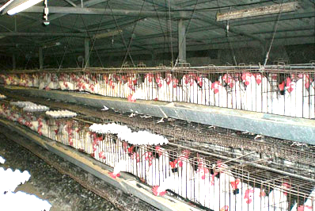

7.
A wild goose is accidentally infected with a virus. This can happen in nature. As long as the goose does not have close contact with many other birds, the virus cannot spread quickly.
8.
Many of the chickens have fallen ill. But before anyone notices, the chickens are sold and sent to other towns. Some are even sent to other countries. The chickens are loaded onto lorries and off they go. The virus goes with them, and so it keeps spreading.
9.
One day, the wild goose is flying over a huge chicken farm when she suddenly loses a feather. The feather happens to fall into the chicken shed. There are a lot of chickens here, all crowded together. In the overcrowded chicken shed, the virus on the sick goose’s feather can quickly spread.

Solutions for Worksheet 2

Story 1 (bats):
A 3 > C 1 > B 2

Story 2 (rats):
F 5 > D 4 > E 6

Story 3 (wild geese):
H 7> I 9 > G8

Image rights

Chickens (photo A): ר ק., ITamar K. / commons.wikimedia.org / Public Domain
Market (photo B): pxhere.com / CC0
Bat (photo C): Dustinthewind / pixabay.com / Pixabay Lizenz
Lorry (photo D): falco / pixabay.com / Pixabay Lizenz
Logging (photo E): Nadav Hurvitz / pexels.com / kostenlose Nutzung
Animals in a cage (photo F): Dan Bennet / commons.wikimedia.org / CC BY 2.0
Rainforest (photo G): K. Yoganand / commons.wikimedia.org/ CC BY-SA 4.0
Wild goose (photo H): Alexas_Fotos / pixabay.com / Pixabay Lizenz
Man (photo I): USAID Biodiversity & Forestry / commons.wikimedia.org / Public Domain

